**Implementation 1: Fileless Malware in Memory (Using PowerShell + Metasploit)**

Metasploit installed

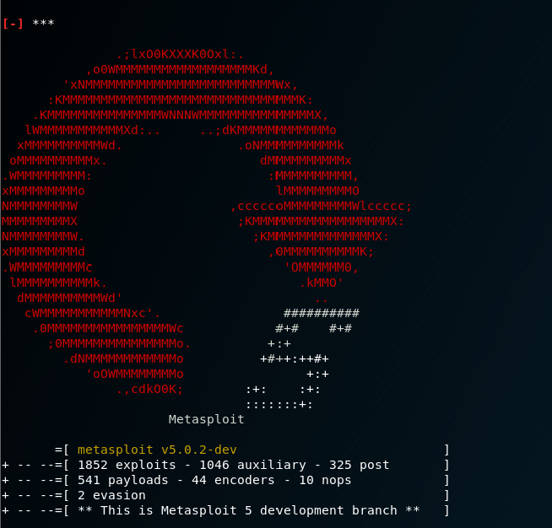

Apache2 webserver installed

